How to download Git?

**Step1**

To download the Git installer, visit the Git's official site and go to download page. The link for the download page is <https://git-scm.com/downloads>. The page looks like as

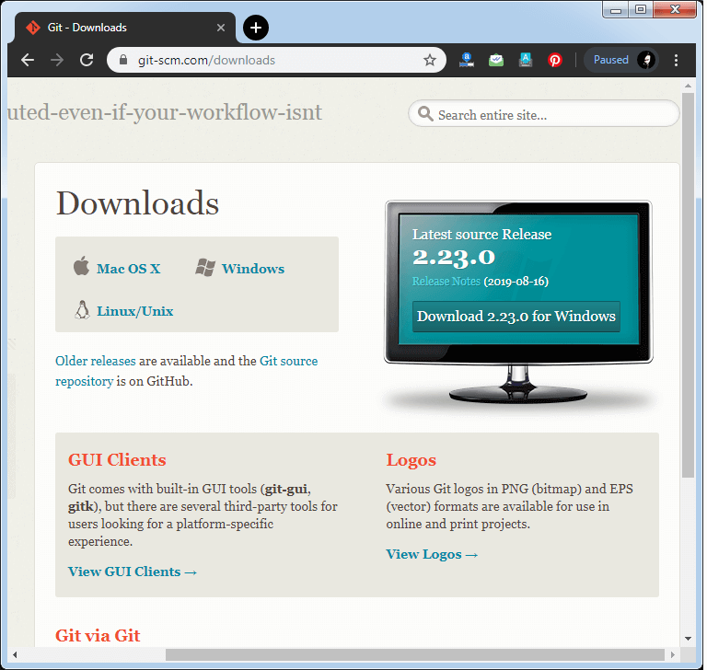

Click on the package given on the page as **download 2.23.0 for windows**. The download will start after selecting the package.

Now, the Git installer package has been downloaded.

Install Git

**Step2**

Click on the downloaded installer file and select **yes** to continue. After the selecting **yes** the installation begins, and the screen will look like as

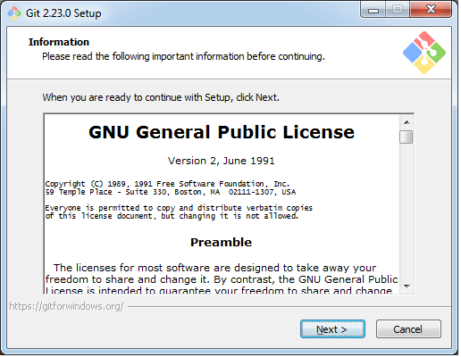

Click on **next** to continue.

**Step3**

Default components are automatically selected in this step. You can also choose your required part.

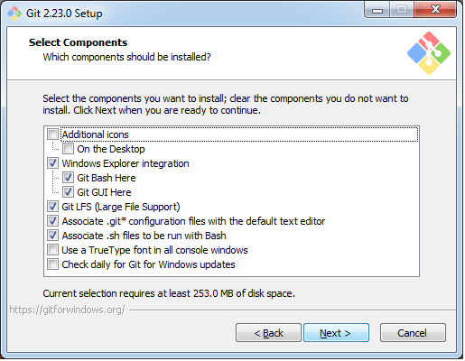

Click next to continue.

**Step4**

The default Git command-line options are selected automatically. You can choose your preferred choice. Click **next** to continue.

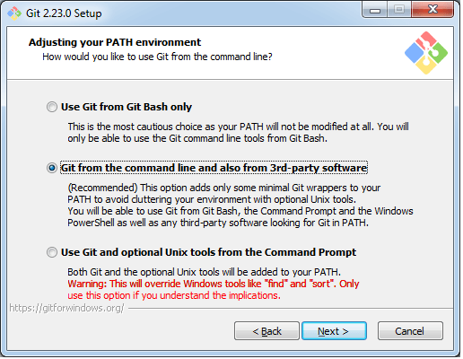

**Step5**

The default transport backend options are selected in this step. Click **next** to continue.

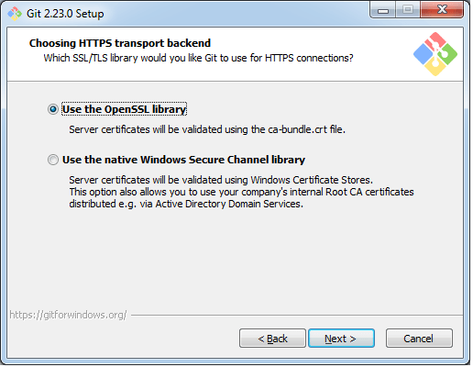

**Step6**

Select your required line ending option and click next to continue.

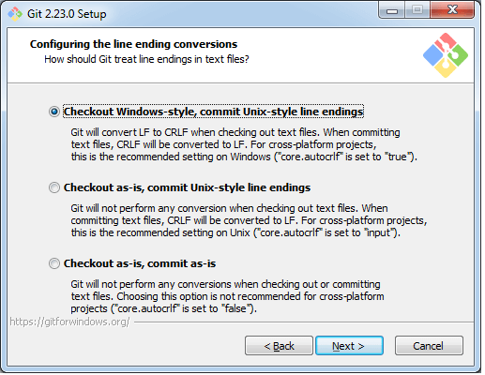

**Step7**

Select preferred terminal emulator clicks on the **next** to continue.

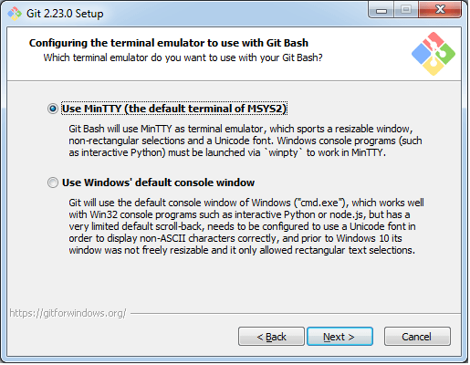

**Step8**

This is the last step that provides some extra features like system caching, credential management and symbolic link. Select the required features and click on the **next** option.

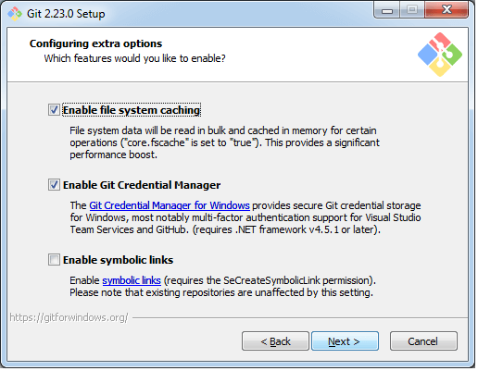

**Step9**

The files are being extracted in this step.

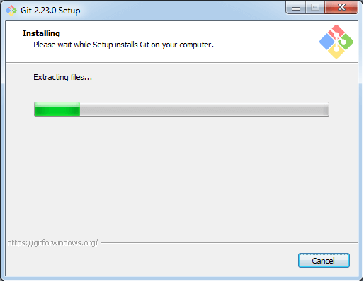

Therefore, The Git installation is completed. Now you can access the **Git Gui** and **Git Bash**.

The **Git Gui** looks like as

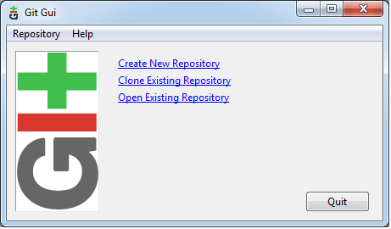

It facilitates with three features.

* Create New Repository
* Clone Existing Repository
* Open Existing Repository

The **Git Bash** looks like as

